



**A.M.A.L. DEGREE COLLEGE, Anakapalle** 

Project submitted by:-

team leader: choudhury venkatsai dilip

team member:-

* badapu laxmankumar
* maradana siva kumar
* merugu mahesh babu

# CERTIFICATE

*This is to certify that* ***Mr.CHOUDHURY VENKATSAI DILIP*** *Reg. No****:-720120105032*** *has completed his internship project (6thsemester) in APSCHE (SmartBridge Long-Term Virtual internship program) on “SOFTWARE TESTING AUTOMATION” under my supervision as a part partial fulfillment of the requirement for the Degree in the stream of B.Sc. (M.P.C),A.M.A.L. College, Anakapalli.*

**DECLARATION**

I **Mr. CHOUDHURY VENKATSAI DILIP** a student of A.M.A.L College Anakapalle Reg. No**:- 720120105032** of the Department of B.sc(M.P.C) here by declare that I have completed the Manadatory internship project on **“SOFTWARE TESTING AUTOMATION”** under the guidance of D.W.J VICTOR Department of Mathematics in A.M.A.L. College.

Calendly Manual Testing

Calendly is an online scheduling tool that allows individuals and businesses to easily manage and schedule appointments, meetings, and events. It simplifies the process of finding mutually convenient meeting times by eliminating the need for back-and-forth email exchanges or phone calls.

With Calendly, users can create personalized scheduling links that they can share with others. When someone wants to schedule a meeting, they can simply click on the link, view the available time slots, and select a time that works best for them. Once a time is chosen, Calendly automatically sends confirmation notifications to all parties involved, and the meeting is added to everyone's calendar.

Calendly integrates with popular calendar platforms such as Google Calendar, Outlook, and iCloud, ensuring that your schedule remains up-to-date and conflicts are avoided. It also offers features like automated reminders, customizable event types, time zone detection, and the ability to set buffer times between appointments.

Overall, Calendly streamlines the process of scheduling meetings and saves time for both individuals and businesses by eliminating the need for manual coordination and back-and-forth communication.

# Calendly HOME PAGE:

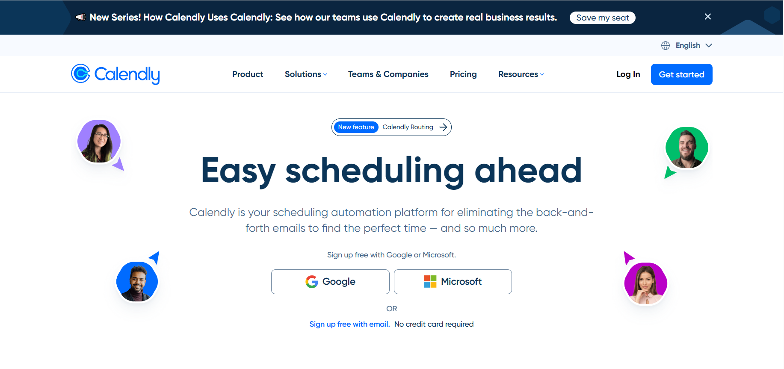

Link: https://calendly.com/

**Project Flow:**

1. Sign up and create an account: Visit the Calendly website and sign up for an account. You may have the option to choose a free plan or select from various paid plans with additional features.

2. Set up your availability: Connect Calendly to your preferred calendar platform, such as Google Calendar or Outlook. This ensures that your availability is synced, and Calendly can detect when you are free or busy.

3. Customize your scheduling preferences: Configure your scheduling preferences within Calendly. This includes setting your working hours, defining appointment lengths, and specifying buffer times between appointments.

4. Create event types: Define different types of events you want to schedule, such as meetings, phone calls, or consultations. Customize the settings for each event type, including the duration, location (if applicable), and any required information you need from participants.

5. Generate scheduling links: Calendly allows you to generate unique scheduling links for each event type or specific time slots. These links can be shared with individuals or embedded on your website or email signature.

6. Share your scheduling links: Share the scheduling links with the people you want to schedule appointments with. You can send the links via email, embed them on your website, or include them in your communication materials.

7. Recipients schedule appointments: When someone wants to schedule a meeting with you, they click on the scheduling link you provided. They will see the available time slots based on your availability. They can choose a convenient time, provide any necessary information, and confirm the appointment.

8. Automatic notifications and calendar updates: Calendly sends confirmation notifications to both you and the other participants. The event is automatically added to your calendar and synced with your connected calendar platform. Participants may receive automated reminders before the scheduled event.

9. Manage and reschedule appointments: Calendly provides a dashboard where you can view and manage all your scheduled appointments. You can easily reschedule or cancel appointments if needed, and Calendly will handle the notifications and calendar updates accordingly.

10. Follow-up and integration: After the meeting, you can use Calendly integrations with other tools like CRM systems or email marketing platforms to streamline your workflow and maintain proper communication with participants.

# Modules Structure:

We have different modules in this all the modules are listed below:

* Product
* Solutions

By Role

* + Sales
  + Marketing
  + Customer Success
  + Recruiting
  + Revenue Operations
  + Information Technology

By Industry

* + Technology
  + Financial Services
  + Professional Services
  + Education
* Teams & Companies
* Pricing
* Resources

Learn

* + Customer Services
  + Resource Center
  + Integrations
  + About
  + Blog
  + Help Center

Connect

* + Developers
  + Contact Us
  + Partners
* Login
* Get Started

# Milestone 1: Product Module

## Activity 1: Product module displays Calendly Features, Sign up for free and Talk to sales buttons functionality. we need to validate the page in terms of color ,font ,spacing between words, design

## 

## Link: <https://calendly.com/features>

## 

## Link: <https://calendly.com/features>

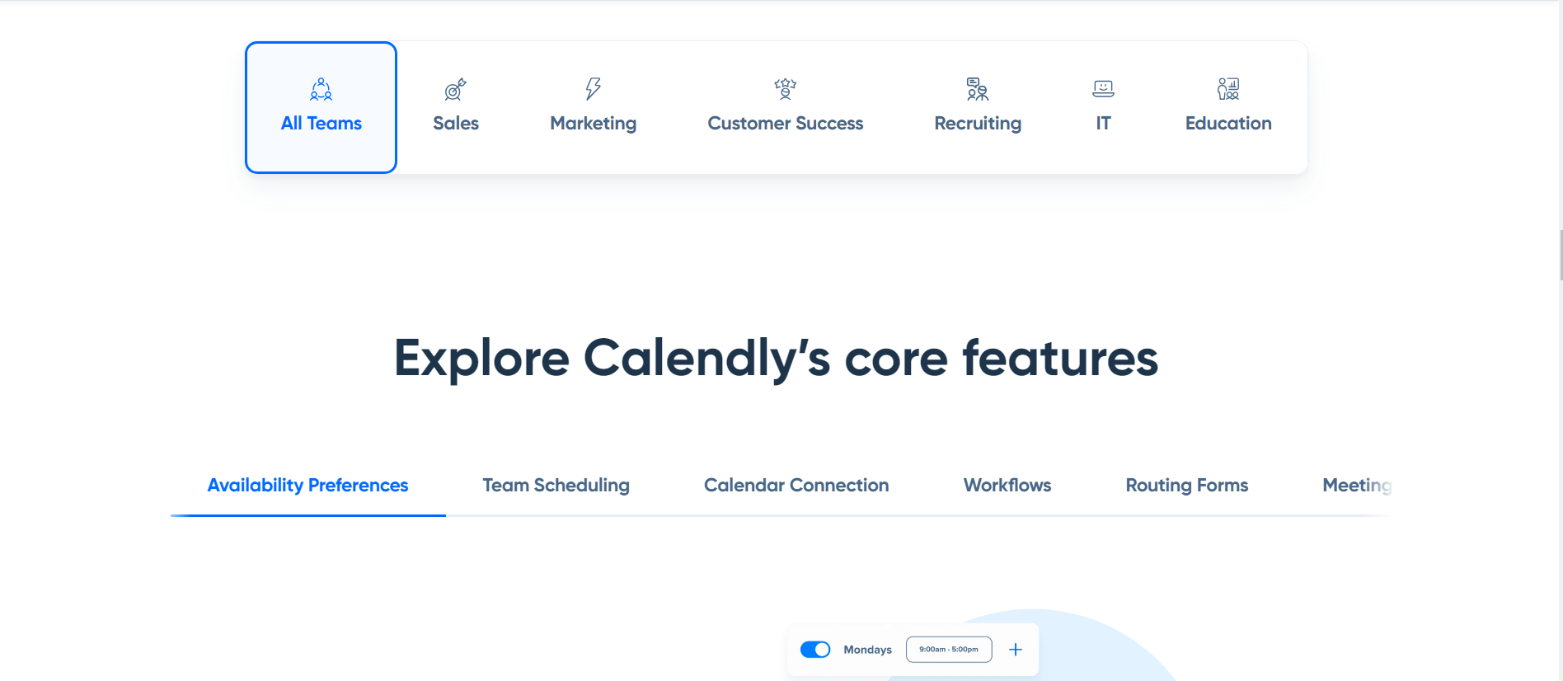

Link: <https://calendly.com/features>

# Milestone 2: Solutions Module

Under Solutions Module we have different sections By Role and By Industry for whom application is suitable for and it also shows different categories of job roles who get benefit from

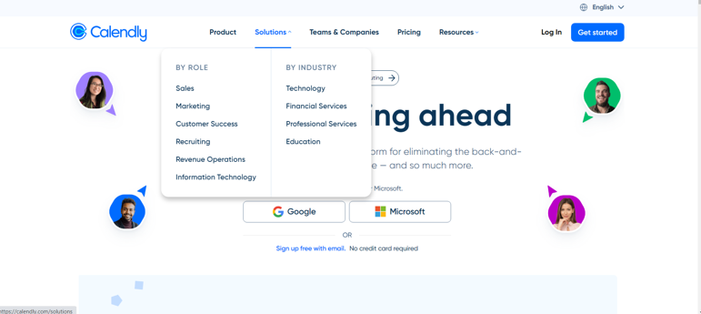

Link: https://calendly.com/

## Activity 1.1: Verifying Sales page functionality and text in terms of color ,font ,spacing between words, design and whole representation

## 

Link: https://calendly.com/solutions/sales

## Activity 1.2: Verifying Sign up for free button functionality and button in terms of color ,font ,spacing between words, design and alignment

## 

# Milestone 3: Verifying Login page functionality

## Activity 1: Verifying login page functionality and UI elements on the page

## 

## Link: <https://calendly.com/>

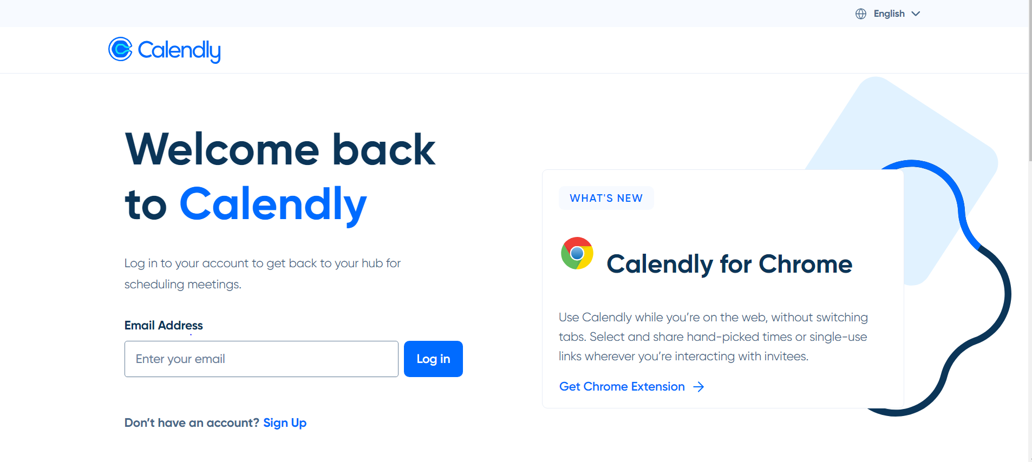

**Link:** https://calendly.com/login

## Activity 1.1: Verifying user is able to enter email id in email address field

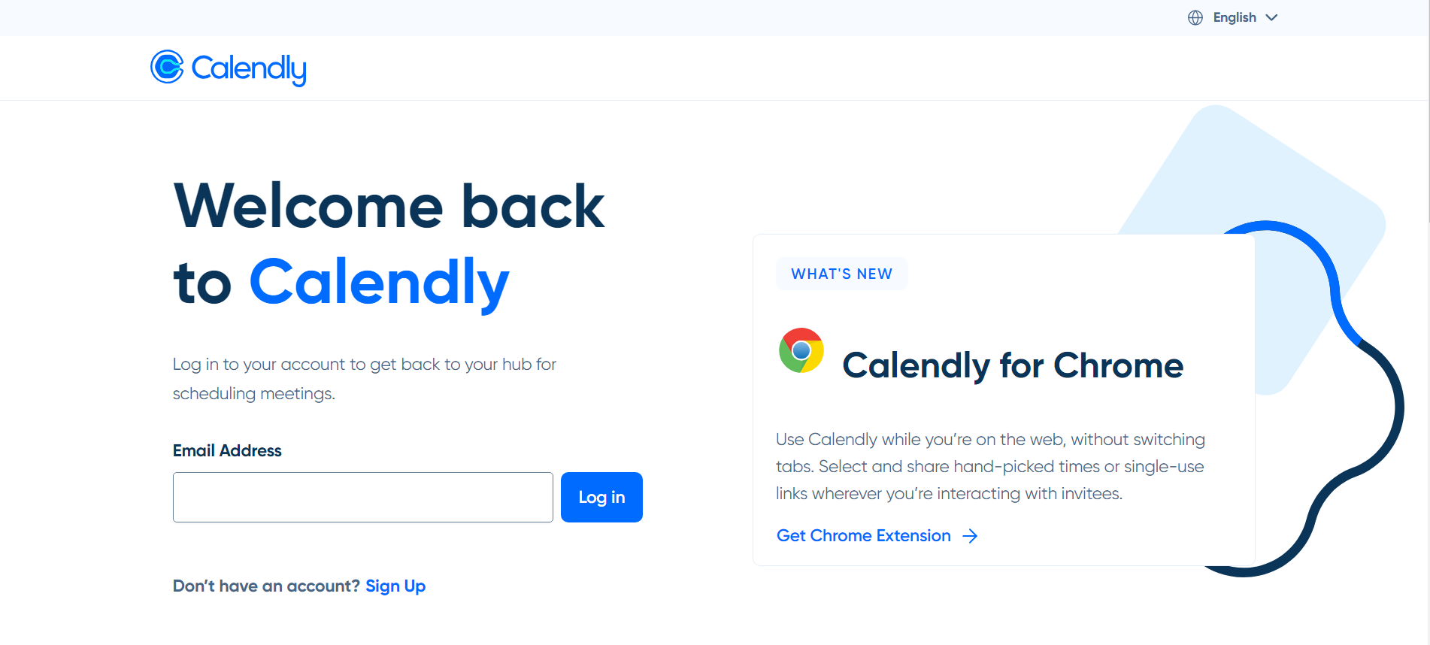

**Link:** https://calendly.com/login

## Activity 2: Verifying behavior of functionality when user not entered email id and validate alert message

**Link:** https://calendly.com/login

# Milestone 4: Verifying Get Started button functionality

## Activity 1: Verifying user is able to click on Try free button and able to see button on top right corner

## Verify user is able to see color ,font, and words alignment of ‘Try free’ text



Link: https://calendly.com/login

## Activity 2: Verifying user is able to enter email id and enter details and Get started functionality

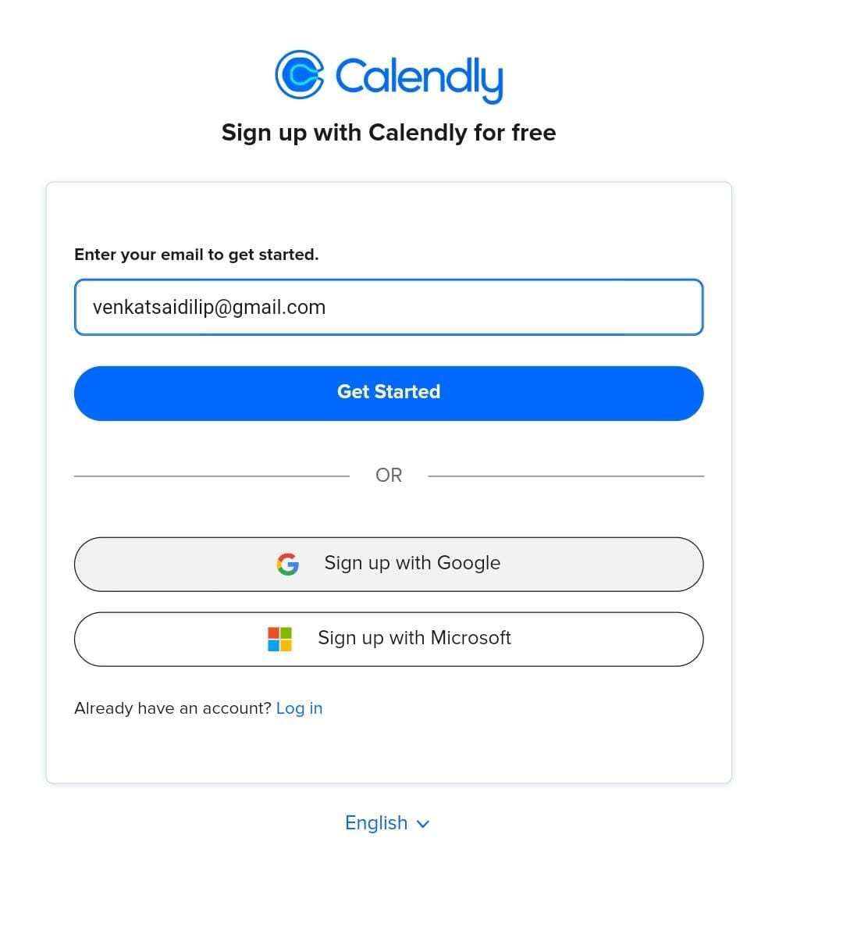

Link: <https://calendly.com/app/signup?lang=en>

## Activity 3: Verifying user is able to click on Click here link for registration

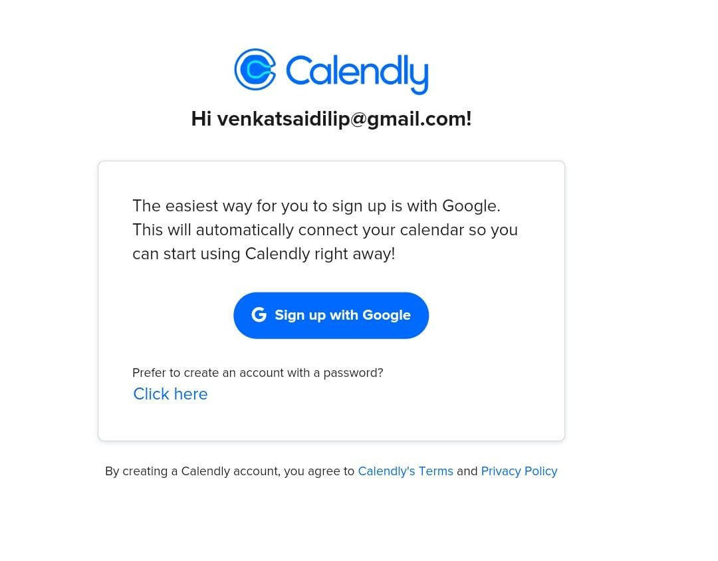

Link: <https://calendly.com/app/signup?lang=en&email=test%40gmail.com>

## Activity 4: Verifying user is able to enter his/her details and continue

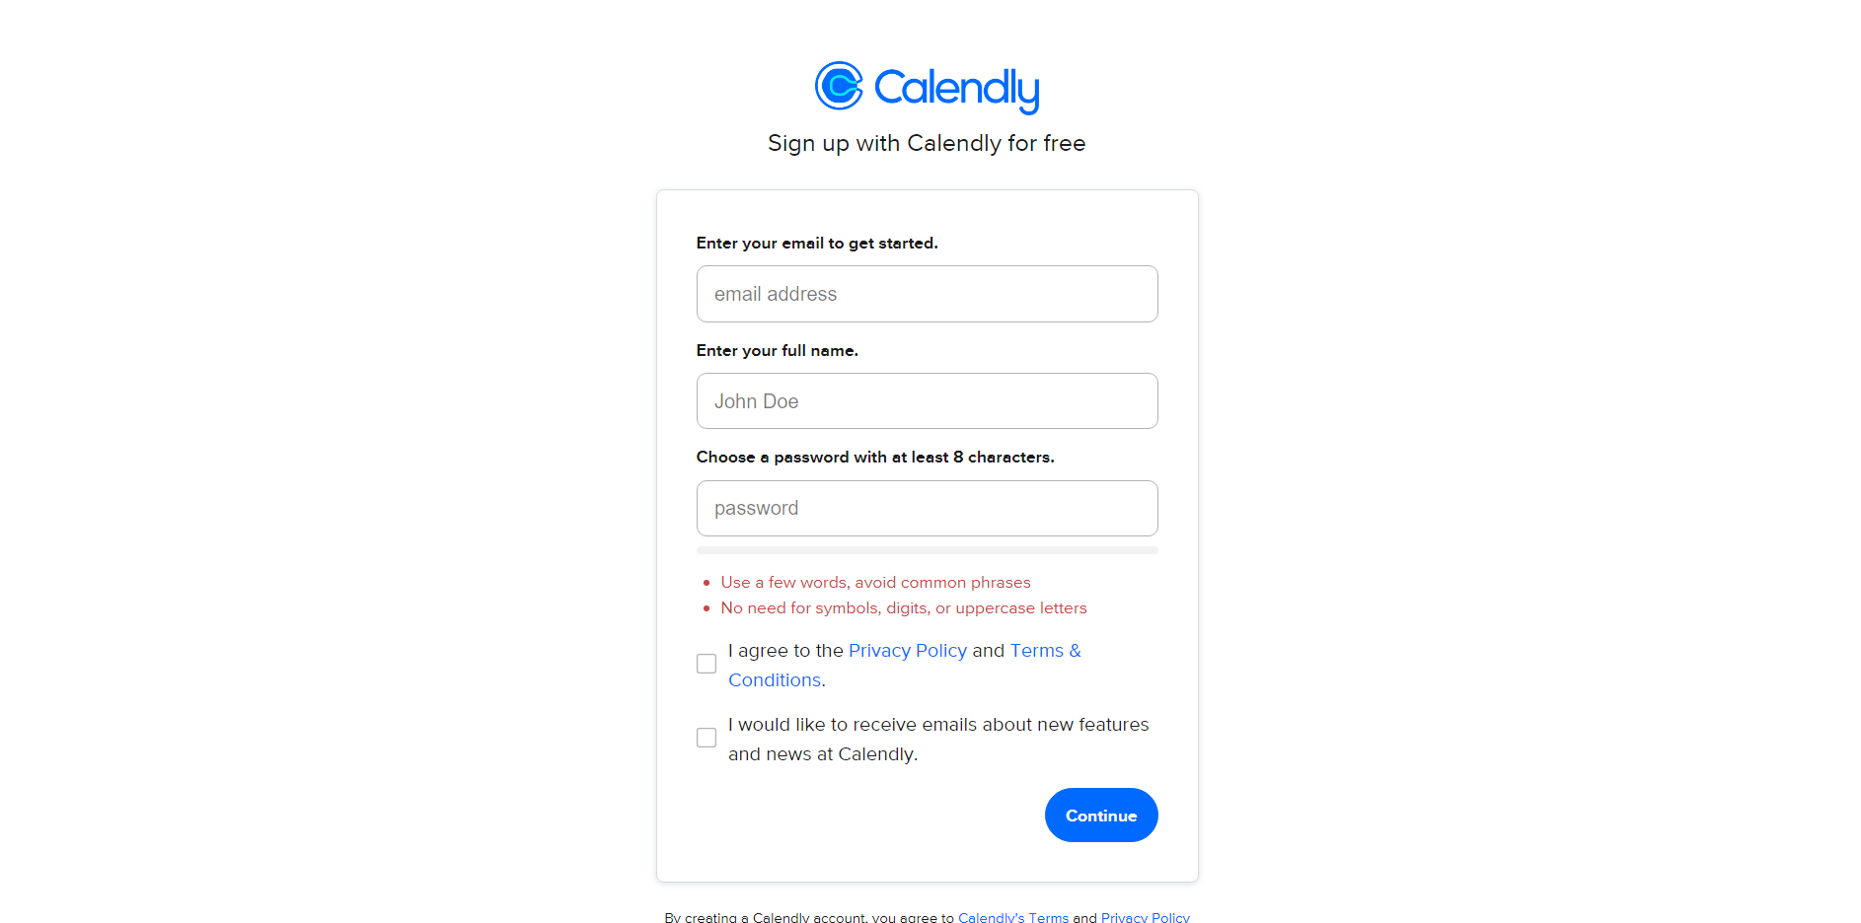

Link: <https://calendly.com/app/signup?lang=en&email=chalam.85%40gmail.com>



## Activity 5:Received an email to confirm and continue verify user is able to enter able to continue

## C:\Users\win7\Downloads\IMG-20230725-WA0008 (1).jpg

## Milestone 5: Verifying Event Types page functionality

## Activity 1: Verifying user is able to create event type and verify text color ,font, and words alignment

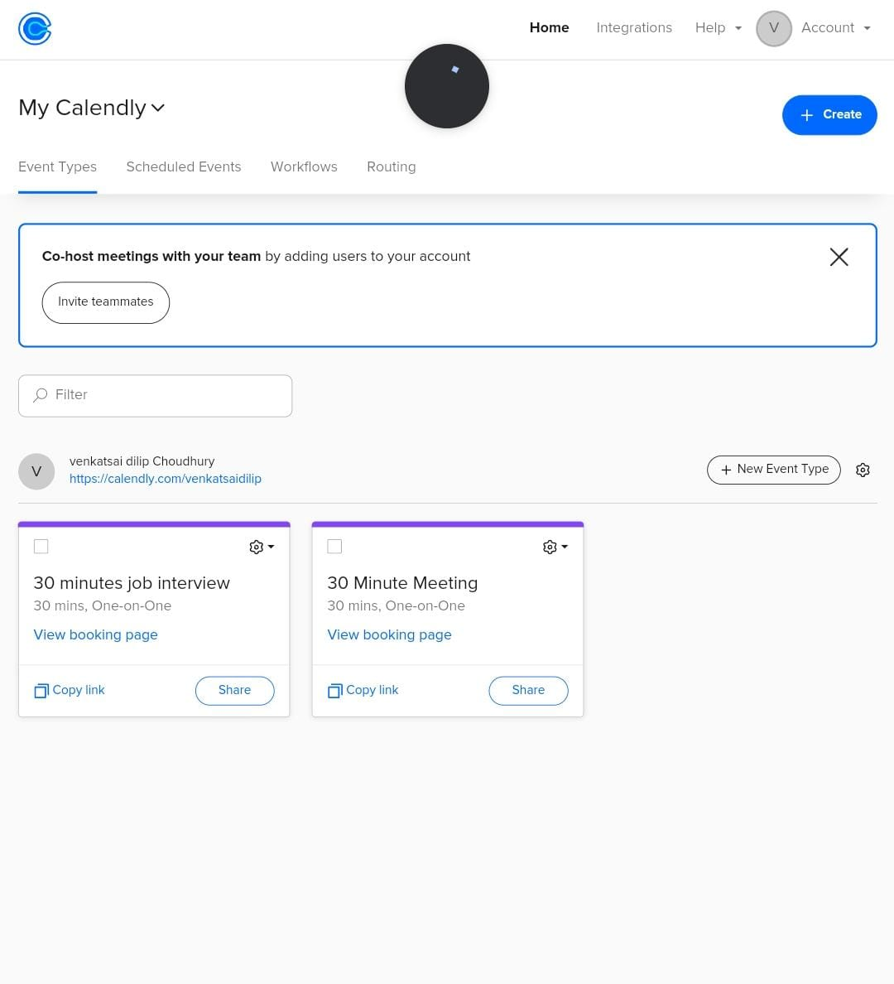

Link: https://calendly.com/event_types/user/me

## Activity 2: Verifying user able to enter any event name and able to select suggested list and click on “+” symbol to add to time tracker for that week

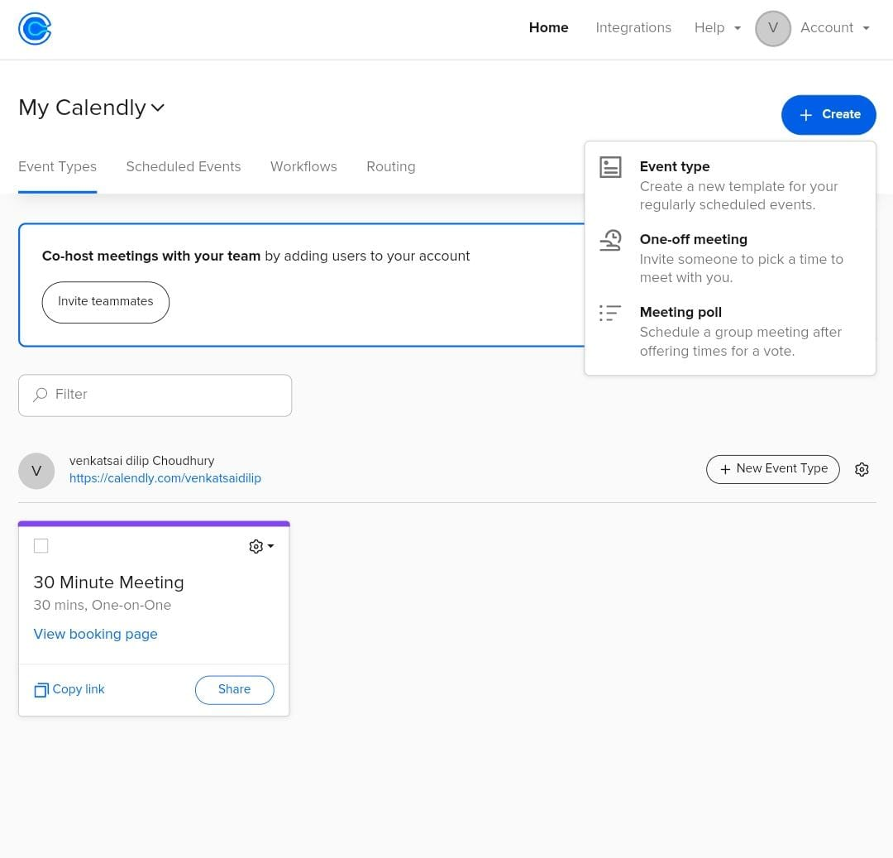

Link: https://calendly.com/event_types/user/me

## Activity 3: Verifying user able to create new event like One-on-One, Group, Collective, Round robin etc.

## C:\Users\win7\Downloads\IMG-20230725-WA0013.jpg

Link: <https://calendly.com/event_types/new?return_to=%2Fevent_types%2Fuser%2Fme>

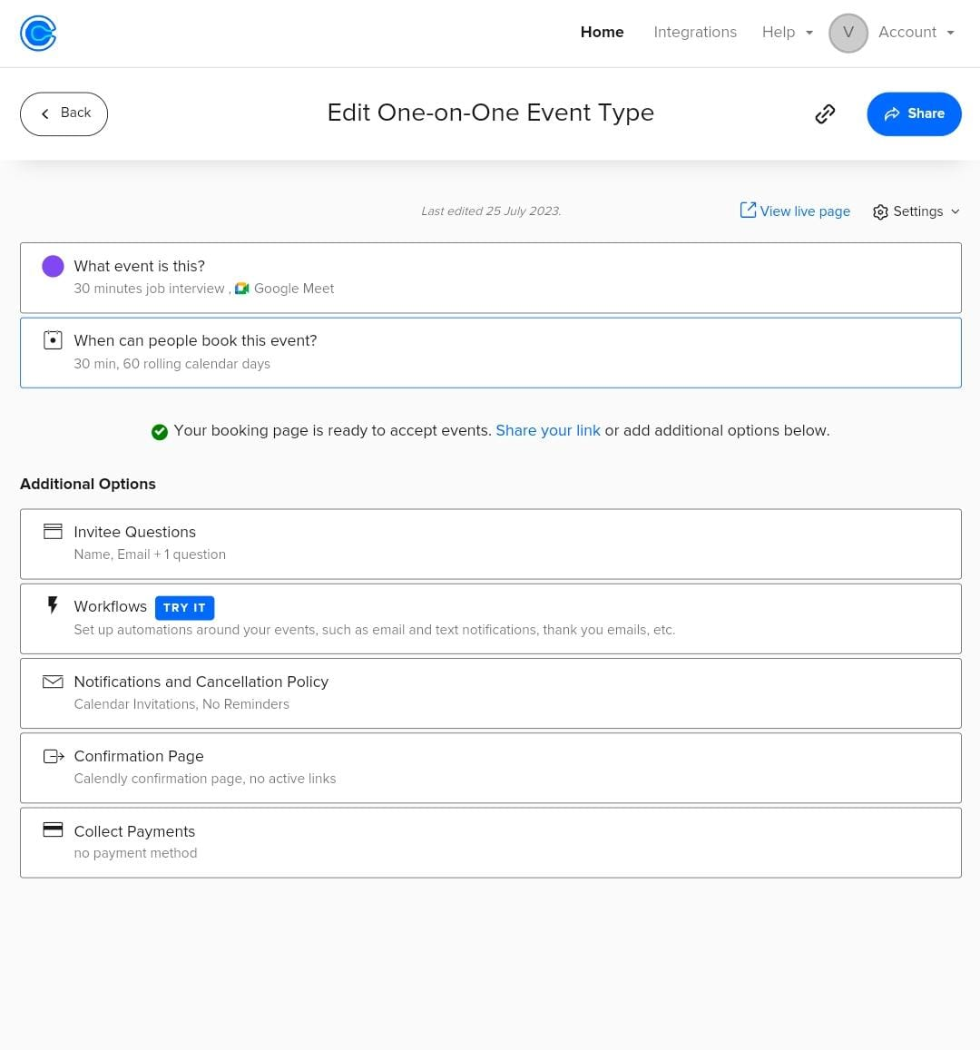

**Final Testing Areas:**

1. Test the Home page elements color, font, alignment, design
2. Test the Log In, Get Started button functionalities
3. Test the modules and sub modules in application
4. Test the links ,buttons are working fine or not
5. Test the user is able to login with valid and invalid credentials
6. Test the user is able to login with Google or Microsoft account on signup page
7. Test the user is able to schedule an event
8. Test the user is able to edit the scheduled event
9. Test the user is able to share the event
10. Test the user is able to track the activity percentage



Automation Testing Calendly

Project based experience learning program

**A.M.A.L. DEGREE COLLEGE, Anakapalle** 

Project submitted by:-

**team leader: choudhury venkatsai dilip**

**team member:-**

* **badapu laxmankumar**
* **maradana siva kumar**
* **merugu mahesh babu**

**Calendly Automation Testing Project**

**About Calendly:**

Calendly is an online scheduling tool that allows individuals and businesses to easily manage and schedule appointments, meetings, and events. It simplifies the process of finding mutually convenient meeting times by eliminating the need for back-and-forth email exchanges or phone calls.

With Calendly, users can create personalized scheduling links that they can share with others. When someone wants to schedule a meeting, they can simply click on the link, view the available time slots, and select a time that works best for them. Once a time is chosen, Calendly automatically sends confirmation notifications to all parties involved, and the meeting is added to everyone's calendar.

Calendly integrates with popular calendar platforms such as Google Calendar, Outlook, and iCloud, ensuring that your schedule remains up-to-date and conflicts are avoided. It also offers features like automated reminders, customizable event types, time zone detection, and the ability to set buffer times between appointments.

Overall, Calendly streamlines the process of scheduling meetings and saves time for both individuals and businesses by eliminating the need for manual coordination and back-and-forth communication.

**Table of Contents**

* Introduction
* Project Overview
* Getting Started
  + Prerequisites
  + Installation
  + Project Setup
* Project Structure
* Writing Test Cases
* Running Tests
* Test Reporting
* Troubleshooting
* Conclusion

**Introduction**

The Calendly project is a Katalon automation project that utilizes the Selenium framework for automating web interactions. This documentation provides an overview of the project, instructions for installation and configuration, details about the project structure, and examples of test cases.

**Project Overview**

The Calendly project aims to automate various tasks on the Calendly website. It leverages Katalon studio, a powerful web automation tool, to interact with web elements and perform actions such as clicking buttons, filling forms, and extracting data.

**Milestone 1: Getting Started**

Explain the prerequisites and setup required to run the project.

**Activity 1:-Prerequisites**

Before getting started with the Calendly project, ensure you have the following prerequisites:

List the software and tools that need to be installed before running the project, such as:

* **Katalon Studio (Latest Version)**
* **Any other dependencies**

**Activity 2:-Installation**

To install the necessary dependencies for the Calendly automation project, follow these steps:

**Activity 2.1:-** Install Katalon Studio: Visit the Katalon Studio website ([https://katalon.com/download](https://katalon.com/download%20) ) and download the latest version of Katalon Studio. Follow the installation instructions for your operating system.

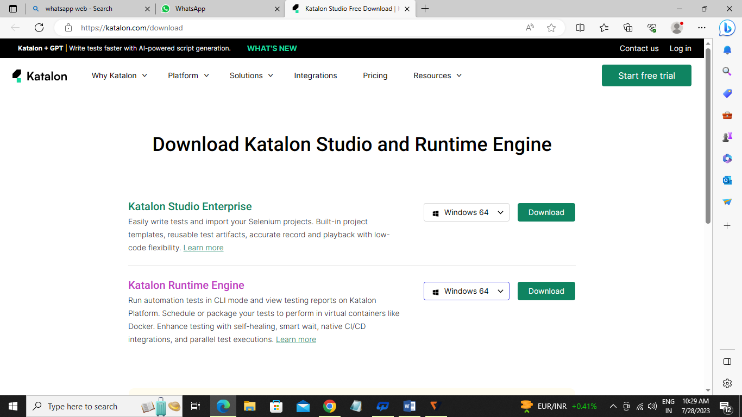

After downloading Katalon Studio and extracting the contents from the zip file, locate the folder where you extracted it.

In that folder, look for the "**katalon.exe**" file. This file is the executable for Katalon Studio.

Double-click on the "**katalon.exe**" file to launch Katalon Studio. It may take a few moments to start up.

Once **Katalon Studio** is launched, you can start creating or opening your project by selecting "File" from the menu bar and choosing either "**New Project**" or "Open Project" based on your requirements.

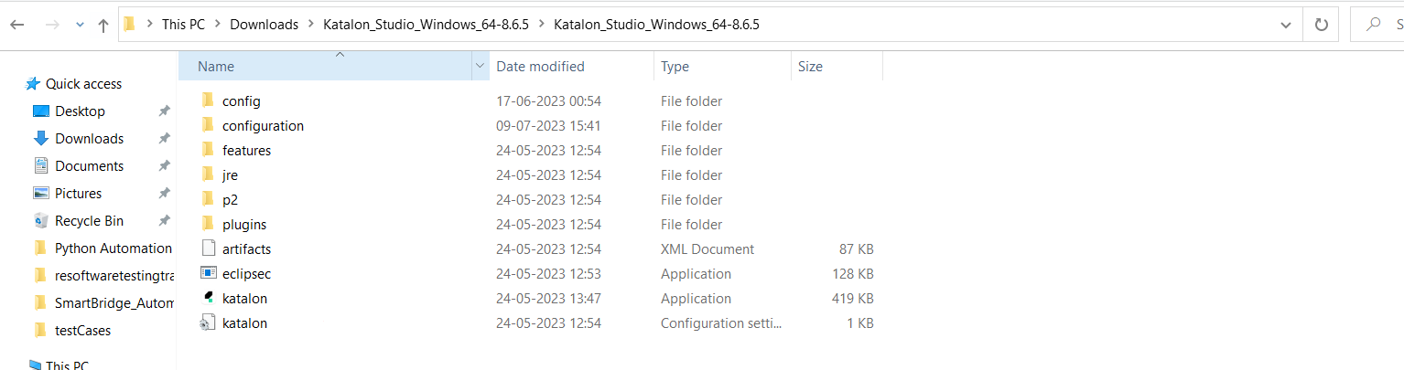

**Activity 2.2:-** Download and install **gitbash** from <https://git-scm.com/download/win>

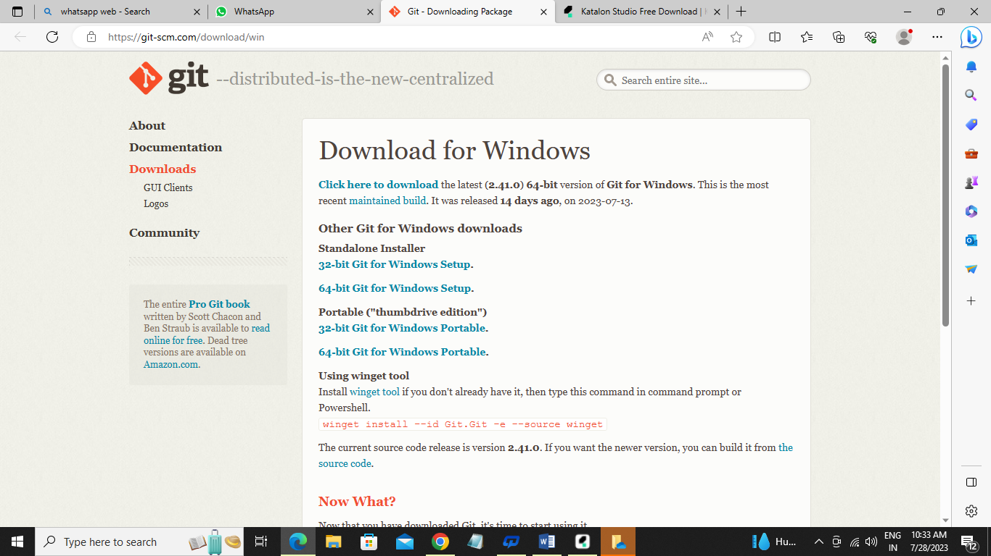

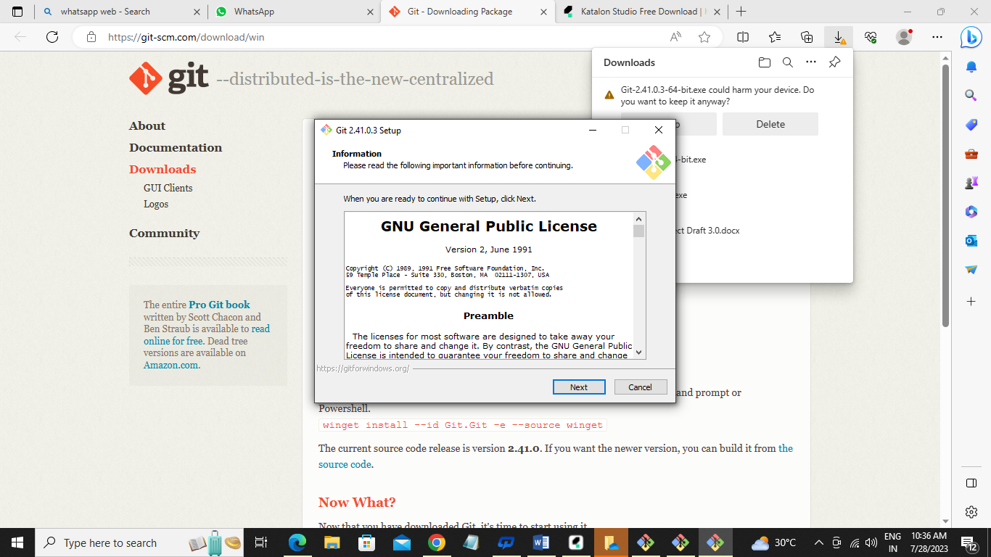

**Activity 2.3:-** Go to the desired location where you want to create the folder, such as Desktop.

Folder name like eg…(Automation_Testing_Project)

Open the folder-🡪 Right click with in the folder and select open gitbash here, you will get pop up like below and clone the repository based on the next steps provided below.

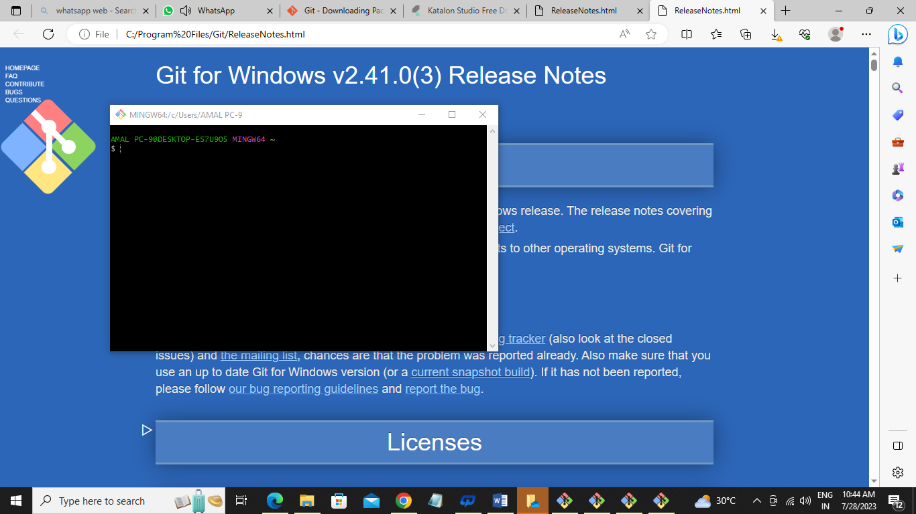

**Activity 3:- Project Setup**

Explained how to set up the project locally, including steps like:

Before cloning the project create project like below in Katalon Studio.

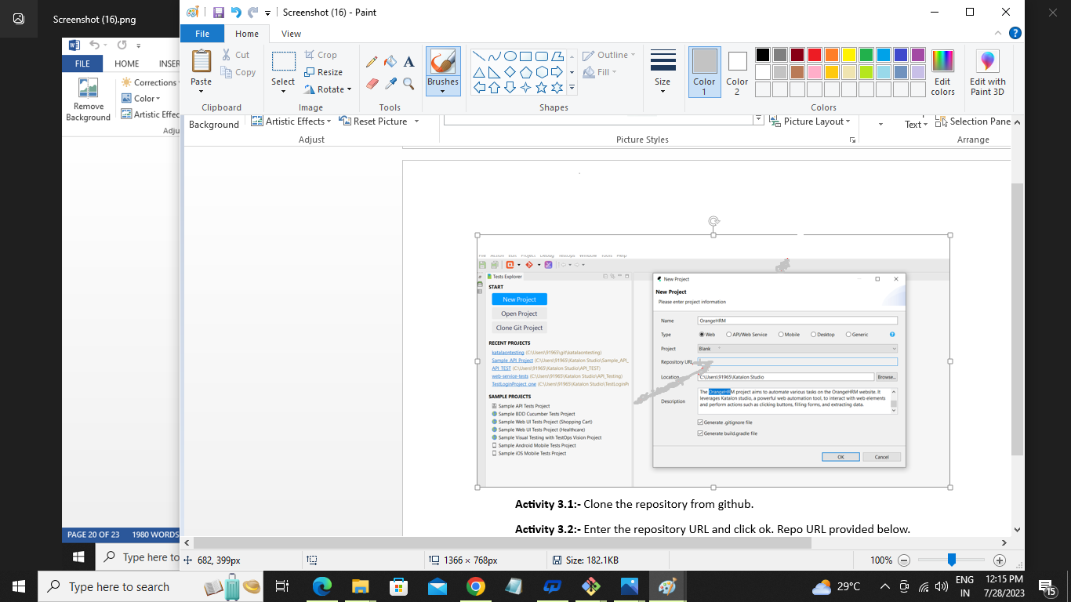

**Activity 3.1:-** Clone the repository from github.

**Activity 3.2:-** Enter the repository URL and click ok. Repo URL provided below.

**Activity 3.3:-** Clone the Calendly project repository from [repository URL].

<https://github.com/venkatsaitesting123/SmartBridge_Automation_Projects.git>

**Activity 3.4:-** Configuration settings (if any)

**Milestone 2: Project Structure**

**Activity 1:-**Explained the structure of the project, including directories and files, and their purposes. For example:

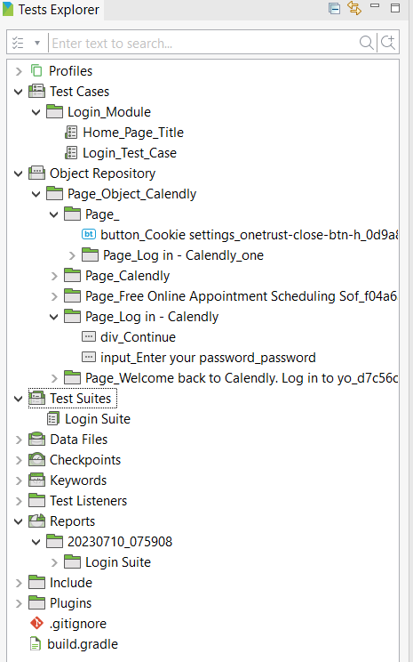

* **testscases/**: Directory containing test scripts
* **ObjectRepository/**: Directory containing page object models
* **testSuites/**: Directory containing run multiple test cases
* **reports/**: Directory containing test reports
* **datafiles/**: Directory containing test data (**ex:excel,csv,text,json files**) related to project
* **Run :- Option to run all the testcases from the top quick access tool bar.**

**Activity 2:-Writing Test Cases**

Explained how to write test cases using Katalon Studio(it uses internally java,groovy script). Provide examples of different types of test cases, such as:

* Test case 1: Home Page functionality

Screenshot of the code:

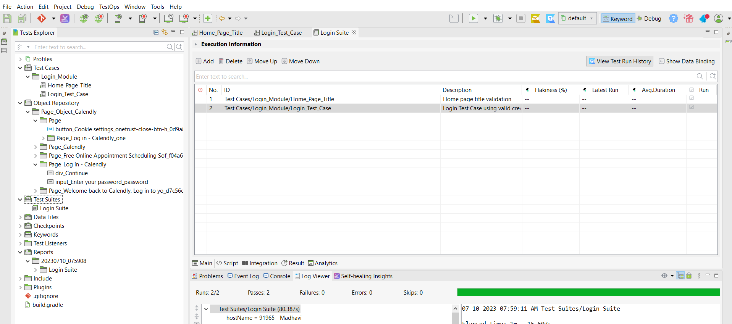

* Test case 2: Register new user functionality
* **Add new testcases as per Manual testcases prepared.**

Include best practices for writing maintainable and readable test cases.

**Milestone 3: Running Tests**

Explained how to run the test cases using Katalon studio. Include information about command-line options and flags that can be used to customize test execution.

**Activity 1:- Option to run all the testcases from the top quick access tool bar.**



**Milestone 4: Test Reporting**

Explained how test reports are generated and where they are stored. Include information about any tools or libraries used for reporting, such as katalon reporting.

**Activity 1:-reports/**: Directory containing test reports

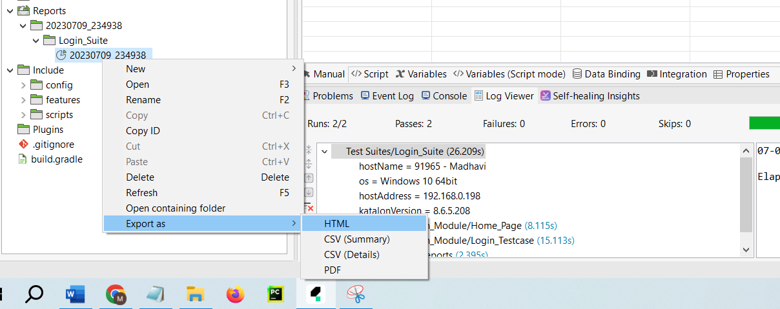

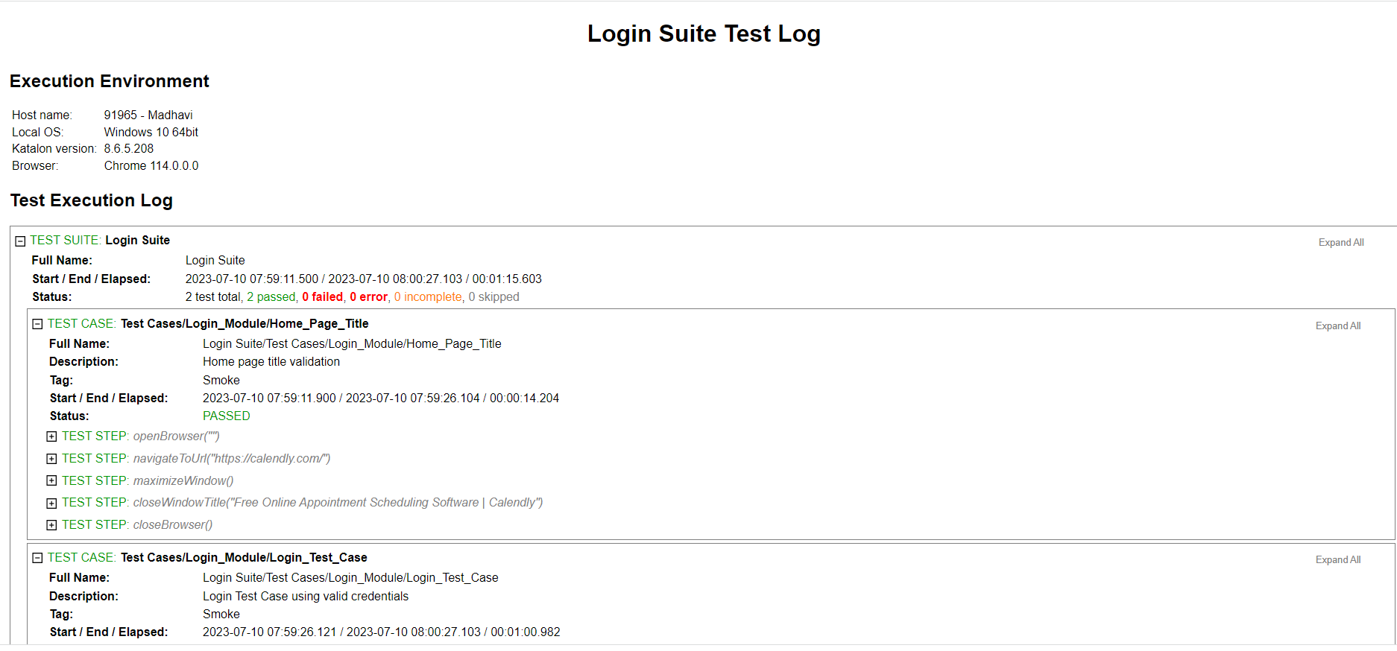

**Troubleshooting**

List common issues that may occur during project setup or test execution and provide possible solutions.

**Conclusion**

The Calendly automation project provides a framework for automating various tasks within the Calendly web application using Katalon Studio. With this documentation, you should be able to set up the project, execute tests, and extend/customize it according to your needs.